by Julia Donaldson

Match the words to the pictures.
1

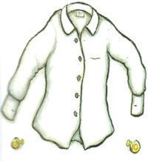
a.

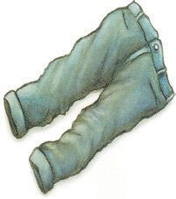
b.
- sandals

- tie

- shirt

- socks

- shoes

- dress

- belt

- trousers

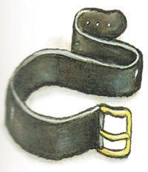
c.

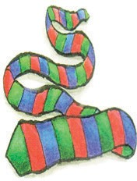
d.

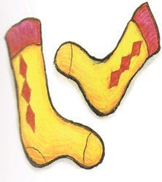
e.

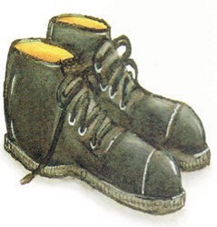
f.

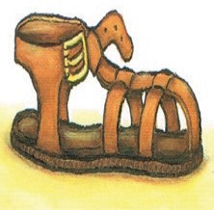
g.

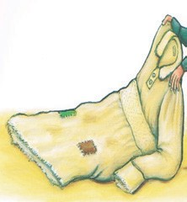
h.

Write the animals and the clothes George the giant gave them.
2

Animal Clothes

1.

2.

3.

4.

5.

sock | mouse | shirt
tie | giraffe | belt
goat | shoe | dog
 | fox

Draw an animal from the story and complete the speech bubble for the animal.
3
The Smartest Giant in Town

I wish I had a
.

Complete the letter to say thank you to George the giant. Use the words from the box to help you. Only use one piece of clothing for number 3 and one animal for number 4.
4
giant
fox you
dog
shoe
goat
belt
tie giraffe
shirt
mouse
sock

Dear George the 1) ,

Thank 2) for the

3) .

I will use it for my 4) .

Your friend,

5) . (your name)

