Tick (√) the animals that appear in the story.
1

frog horse cow bird
√
cat dog
sheep

Match the pictures 1-6 to the words a-f.
2

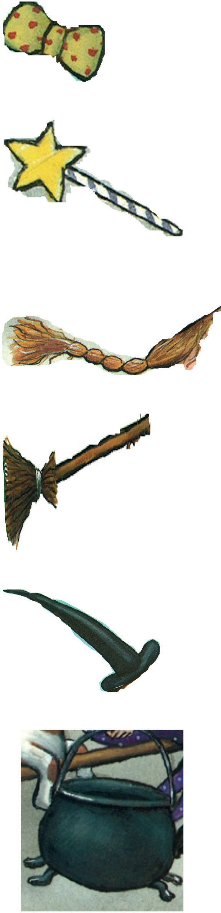

1

2

3

4

5

6
- magic wand

- broom

- plait

- cauldron

- bow

- hat

Look at the picture from the story. Complete the sentences with the correct preposition (on x3, in x2, under x1).
3

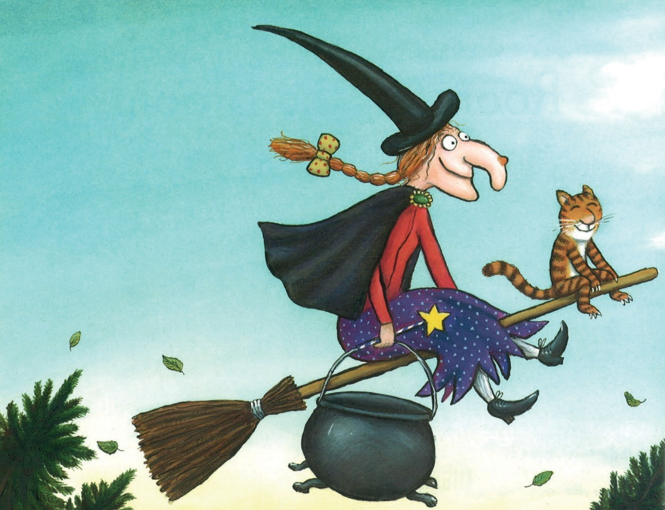

- The magic wand is the witch’s hand.

- The hat is the witch’s head.

- The plait is the witch’s head.

- The broom is the witch.

- The bow is the witch’s plait.

- The cauldron is the witch’s hand.

Draw a picture of the witch on the broom and colour it with your favourite colours. Complete the sentences with a colour to describe your witch.
4

My witch

- My witch has got a plait.

- My witch has got a hat.

- My witch has got a bow.

- My witch has got a magic wand.

- My witch has got a broom.

- My witch has got a cauldron.

5a. Draw your favourite character in the story.

Favourite character

5b. Complete the sentence with your favourite animal from the story and use a word from the box to describe it.
kind funny happy clever

My favourite animal in the story is the because it is
.

