

Unit 2 Test | Higher Total score: /40
Listening

1 Listen and number. Then label. Score: /5
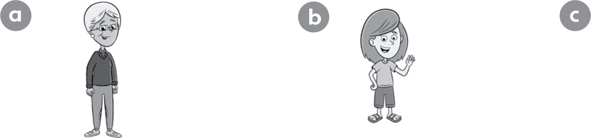



1 sister

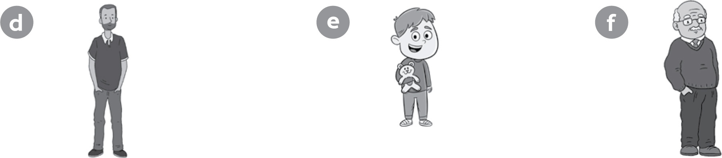




2 Listen and tick ( ) or cross ( ). Correct the false Score: /5
sentences.

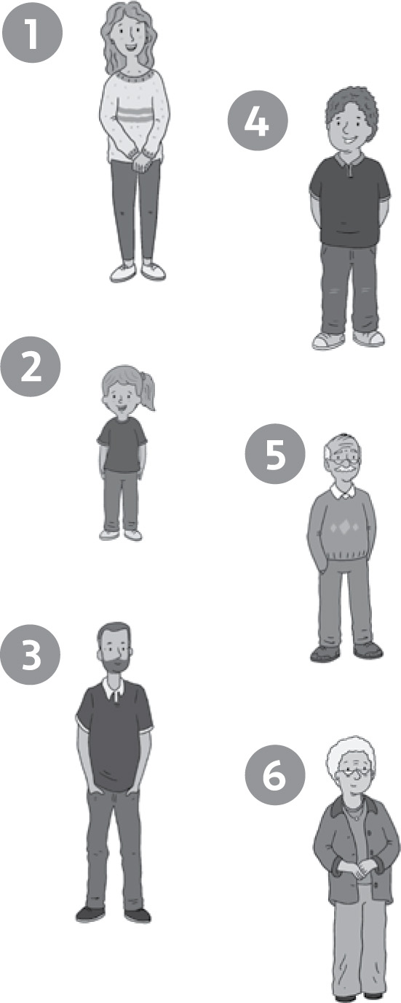

1 This is my aunt. She’s tall. ____
2 My sister is young. _____
_________________________________
3 This is my dad. He’s short. _____
_________________________________
4 This is my uncle. He’s short. _____
_________________________________
5 This is my grandpa. He’s young. _____
_________________________________
6 My grandma is short. _____
_________________________________

Unit 2 Test | Higher
Reading and Writing
3 Look, read and write. Score: /5
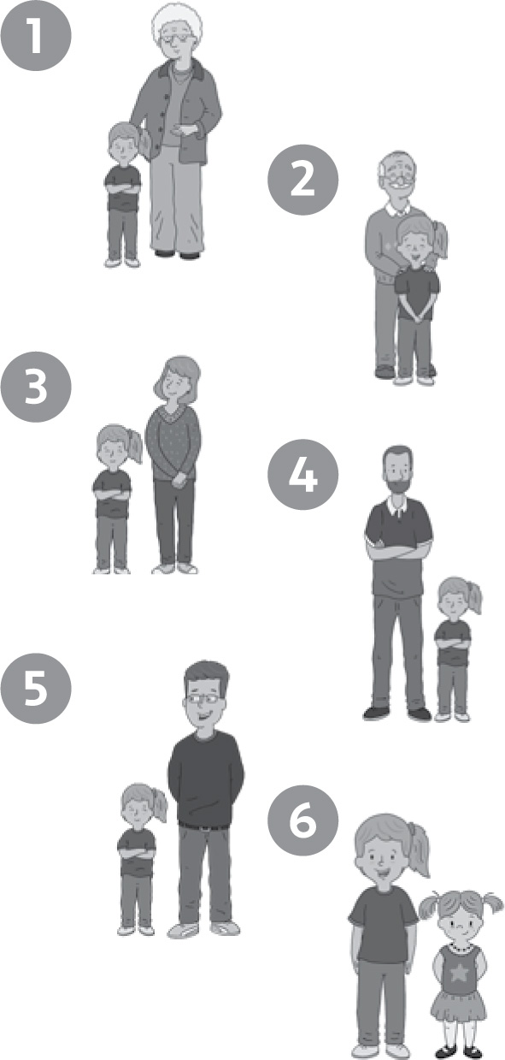
1 This is my grandma. She’s tall.

2 This is my g__________ . He’s o__________ .

3 My m_________ isn’t tall. She’s s_____ __ _.

4 This is my d__________ . He’s t__________ .

5 My u__________ isn’t o__________. He’s young.

6 This is my s__________ . She’s y_________ _ .

4 Look, read and write. Score: _ /5
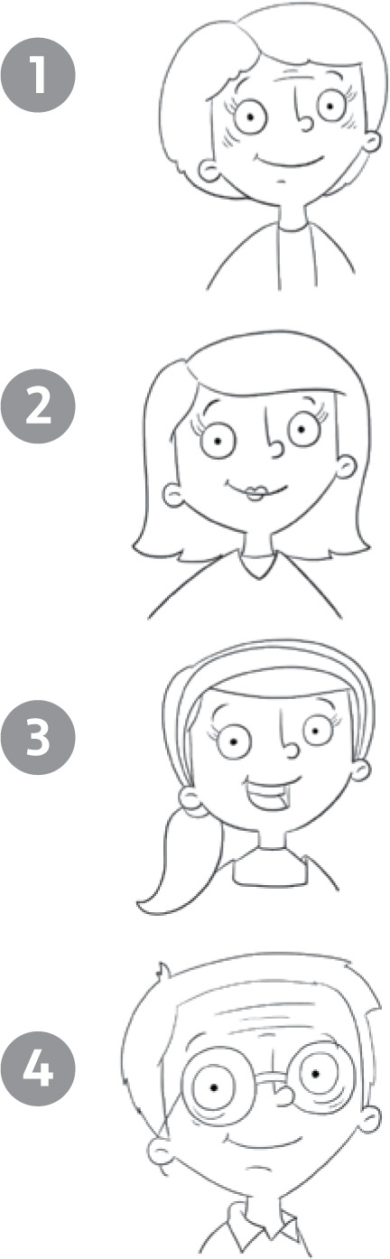
Who’s this? This is my grandma.

___________ this your aunt? Yes, ______________.

Who’s ____________? _______________ my sister.

____________________ dad? No, _____________.

Unit 2 Test | Higher

Speaking
5 Imagine this is your family. Ask and answer. Score: /10
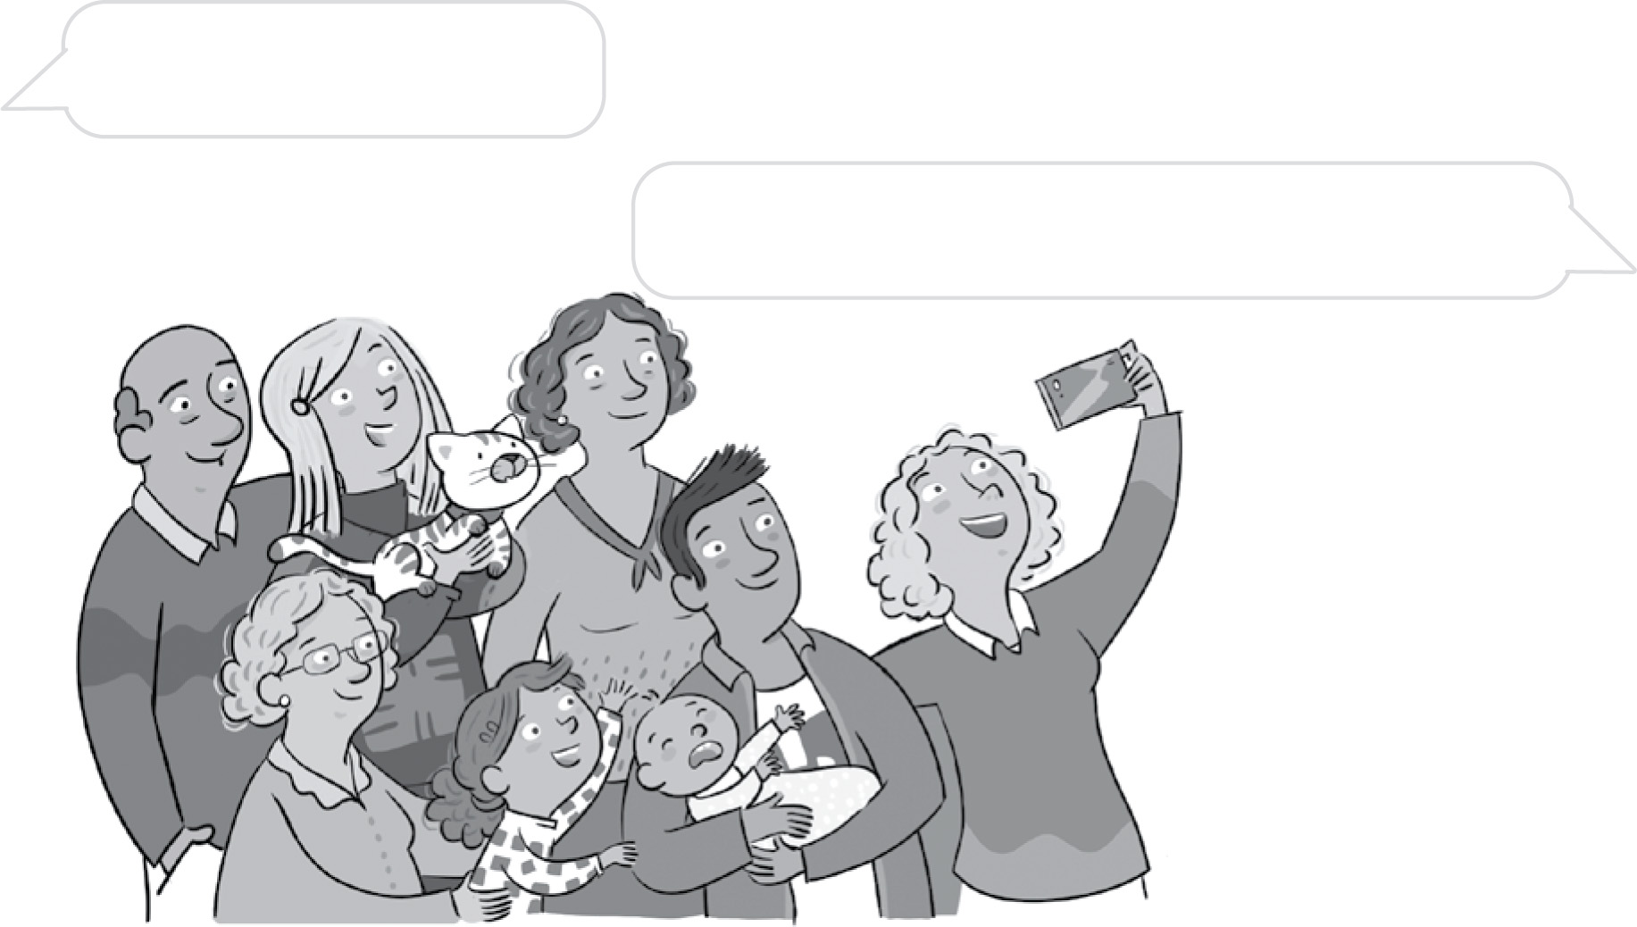
Is this . . . ?

No, it isn’t. This is my . . .

6 Look. Ask and answer. Score: /10

Is Mum short?

No, she . . . She’s . . .

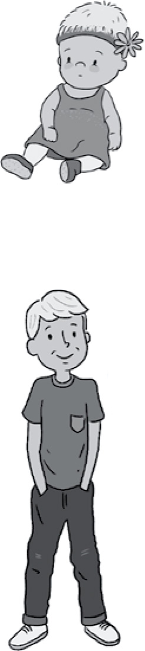
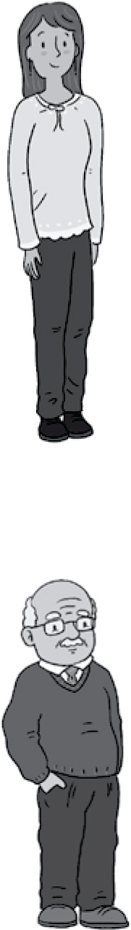
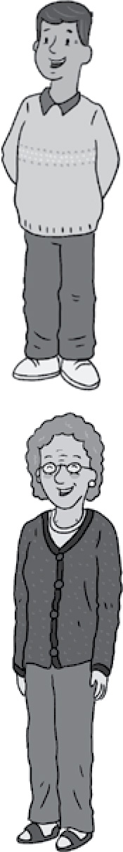


Audio Scripts and Answers

Unit 2 | Higher

Listening
1 Listen and number. Then label.
  - Boy: Hi Julie. Who’s this?
Girl: This is my sister.
- Girl: This is my aunt. She’s young. She’s tall, too.
- Boy: Is this your aunt?
Girl: No, it isn’t! This is my grandma. She’s old.
- Boy: Who’s this?
Girl: This is my grandpa. He’s short.
- Boy: Is this your dad?
Girl: Yes, it is. He’s young!
- Boy: Who’s this?
Girl: The young boy?
Boy: Yes.
Girl: This is my brother.
Answers: 2 c; aunt 3 a; grandma 4 f; grandpa
5 d; dad 6 e; brother

2 Listen and tick (✔) or cross (✘). Correct the false sentences.
- Girl: This is my family.
Boy: Who’s this woman? She’s tall.
Girl: This is my aunt.
- Boy: Is this your sister?
Girl: Yes, it is. She’s young and tall.
- Boy: Is this your uncle?
Girl: No, my uncle is short. This is my dad. He’s tall.
- Boy: Is this your uncle?
Girl: Yes, it is. He’s short.
- Boy: Who’s this?
Girl: This is my grandpa. He’s old. He’s short, too.
- Boy: Who’s this?
Girl: This is my grandma. She’s old. She isn’t short. She’s tall.
Answers: 2 ✔ 3 ✘; He’s tall. 4 ✔ 5 ✘; He’s old.
6 ✘; She’s tall.

Reading and Writing
3 Look, read and write.
Answers: 2 grandpa; old 3 mum; short 4 dad; tall 5 uncle; old 6 sister; young

- Look, read and write.
Answers: 2 Is; it is 3 this; This is 4 Is this your; it isn’t

Speaking
Teaching notes
Award one point per item for accuracy and one point for ability to communicate well.
Activity 5 asks students to recognise and produce the target grammar structure Is this your …?
Is this your grandma? No, it isn’t. This is my aunt.
Read the example question and answer and ask students to repeat. Then ask a question with a positive answer and a question with a negative answer to two different students, pointing at the picture each time. Students should answer and add who the person is for the negative answer. Get students to work in pairs and point to the different people in the picture, using the model dialogue to help them. Students should ask or answer five questions each.
Activity 6 asks students to use adjectives to describe people.
Is Mum short? No, she isn’t. She’s tall.
Read the example question and answer and ask students to repeat. Ask another student Is dad short? and get them to answer. Put students in pairs to take it in turns pointing at the pictures and asking and answering questions. Students should ask or answer five questions each.

5 Imagine this is your family. Ask and answer.
Example answers: Is this your grandpa / mum / dad / uncle / aunt / brother / sister / dog / cat? Yes, it is. No, it isn’t. This is my ...

6 Look. Ask and answer.
Example answers: Is Mum / Dad / Aunt / Uncle / Sister / Grandpa / Grandma / Brother tall / short / young / old?
Yes, she / he is. No, she / he isn’t. She / He’s ...

